Swollen Legs

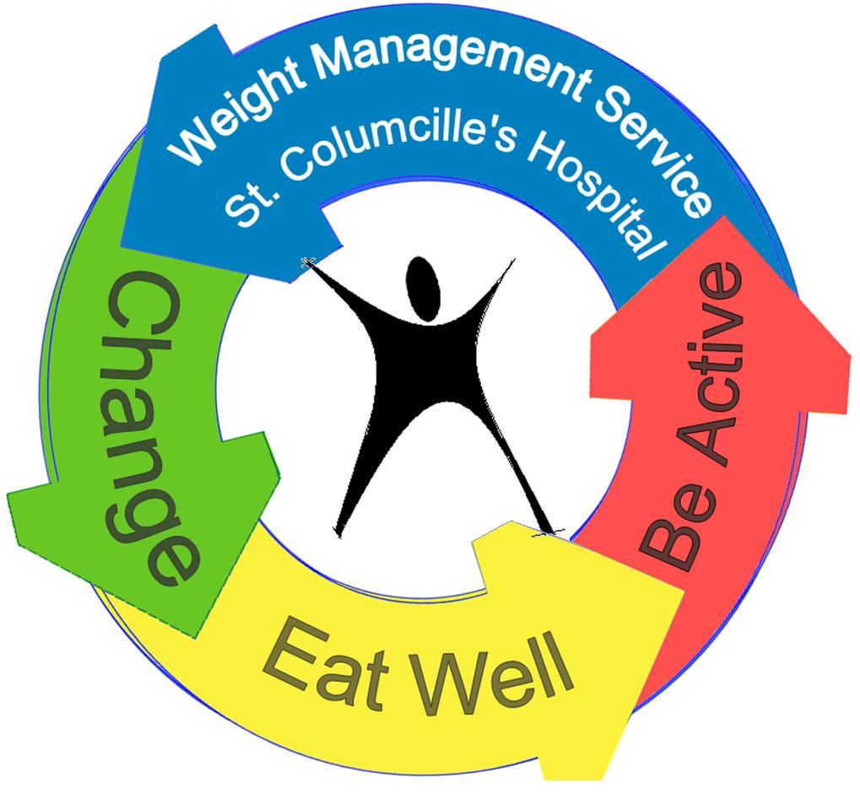





1 in 3 weight management patients suffer with swollen legs. It can cause pain, make moving harder, and lead to skin infections.

Can my leg swelling be treated?

4 Steps to better management:

**Moisturise daily to keep skin supple**

**Move regularly, take lots of little walks**

**At night-time raise your feet up on pillows**

**Wearing flat knit compression can really help**

**Off the shelf:** Ready to wear, flat knit, class 3.

Serranova, Uniphar, JOBST, Mediven, Cost: €60 - 74

**Made to measure:**

Measuredto fit, flat knit, T-heel & silicone band

Compression class 3 Cost: Pair €200-300

**FarrowWrap:**

Measuredto fit, Velcro straps - Cost: Pair €200-300 Available in beige, black, dark blue, grey, dark brown



Free phone helpline: 1800 200 700

[www.lymphireland.com](http://www.lymphireland.com)