My main challenge was: _________________________________________________________________________________________________





**Bladder & Bowel diary**

Please fill out this diary as best you can.

|  |  |  |  |  |  |
| --- | --- | --- | --- | --- | --- |
| **Time of day:** | Fluid/Medication intake  (Type/mls) | Pee amount/time  (Small, Med, Large) | Leakage amount (Small, Med, Large) | Activity with leakage +/- urge | Bowel movements – Stool type |
| 06:00 |  |  |  |  |  |
| 07:00 |  |  |  |  |  |
| 08:00 |  |  |  |  |  |
| 09:00 |  |  |  |  |  |
| 10:00 |  |  |  |  |  |
| 11:00 |  |  |  |  |  |
| 13:00 |  |  |  |  |  |
| 14:00 |  |  |  |  |  |
| 15:00 |  |  |  |  |  |
| 16:00 |  |  |  |  |  |
| 17:00 |  |  |  |  |  |
| 18:00 |  |  |  |  |  |
| 19:00 |  |  |  |  |  |
| 20:00 |  |  |  |  |  |
| 21:00 |  |  |  |  |  |
| 22:00 |  |  |  |  |  |
| 23:00 |  |  |  |  |  |
| 00:00 |  |  |  |  |  |
| 01:00 |  |  |  |  |  |
| 02:00 |  |  |  |  |  |
| 03:00 |  |  |  |  |  |
| 04:00 |  |  |  |  |  |
| 05:00 |  |  |  |  |  |





**Bladder & Bowel diary**

Please fill out this diary as best you can.

|  |  |  |  |  |  |
| --- | --- | --- | --- | --- | --- |
| **Time of day:** | Fluid/Medication intake  (Type/mls) | Pee amount/time  (Small, Med, Large) | Leakage amount (Small, Med, Large) | Activity with leakage +/- urge | Bowel movements – Stool type |
| 06:00 |  |  |  |  |  |
| 07:00 |  |  |  |  |  |
| 08:00 |  |  |  |  |  |
| 09:00 |  |  |  |  |  |
| 10:00 |  |  |  |  |  |
| 11:00 |  |  |  |  |  |
| 13:00 |  |  |  |  |  |
| 14:00 |  |  |  |  |  |
| 15:00 |  |  |  |  |  |
| 16:00 |  |  |  |  |  |
| 17:00 |  |  |  |  |  |
| 18:00 |  |  |  |  |  |
| 19:00 |  |  |  |  |  |
| 20:00 |  |  |  |  |  |
| 21:00 |  |  |  |  |  |
| 22:00 |  |  |  |  |  |
| 23:00 |  |  |  |  |  |
| 00:00 |  |  |  |  |  |
| 01:00 |  |  |  |  |  |
| 02:00 |  |  |  |  |  |
| 03:00 |  |  |  |  |  |
| 04:00 |  |  |  |  |  |
| 05:00 |  |  |  |  |  |

My main challenge was: ________________________________________________________________________________________________





**Bladder & Bowel diary**

Please fill out this diary as best you can.

|  |  |  |  |  |  |
| --- | --- | --- | --- | --- | --- |
| **Time of day:** | Fluid/Medication intake  (Type/mls) | Pee amount/time  (Small, Med, Large) | Leakage amount (Small, Med, Large) | Activity with leakage +/- urge | Bowel movements – Stool type |
| 06:00 |  |  |  |  |  |
| 07:00 |  |  |  |  |  |
| 08:00 |  |  |  |  |  |
| 09:00 |  |  |  |  |  |
| 10:00 |  |  |  |  |  |
| 11:00 |  |  |  |  |  |
| 13:00 |  |  |  |  |  |
| 14:00 |  |  |  |  |  |
| 15:00 |  |  |  |  |  |
| 16:00 |  |  |  |  |  |
| 17:00 |  |  |  |  |  |
| 18:00 |  |  |  |  |  |
| 19:00 |  |  |  |  |  |
| 20:00 |  |  |  |  |  |
| 21:00 |  |  |  |  |  |
| 22:00 |  |  |  |  |  |
| 23:00 |  |  |  |  |  |
| 00:00 |  |  |  |  |  |
| 01:00 |  |  |  |  |  |
| 02:00 |  |  |  |  |  |
| 03:00 |  |  |  |  |  |
| 04:00 |  |  |  |  |  |
| 05:00 |  |  |  |  |  |

My main challenge was: ________________________________________________________________________________________________

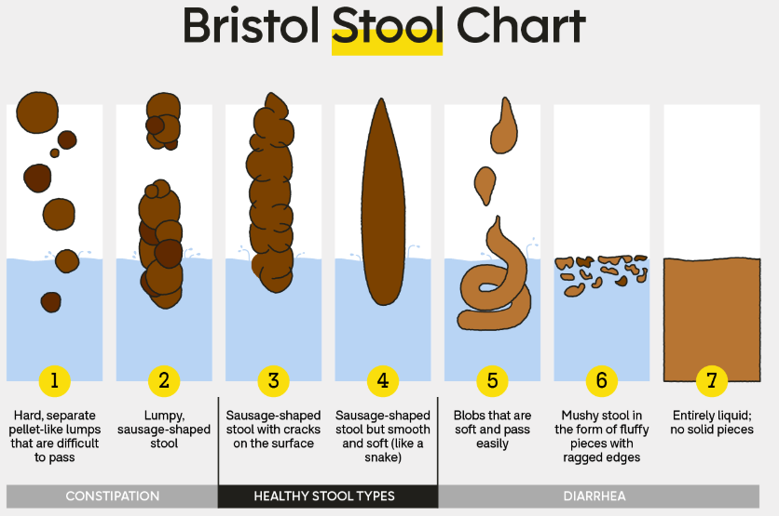

Toileting position

Pelvic health resources

* Aim for type 3 or 4, 3 times/day to once every 3 days by balancing fibre & fluid.
* Aim for 1.5-2L of water & 3 regular meals a day.
* Type 1-2: Add fibre/water.
* Type 5-7: Try a lower fibre diet.
* No ‘one diet fits all’ and it often takes time to find the right balance.

*Image: GoodRx.com*

* Complete for 3 consecutive days.
* Write down everything you eat & drink, including medication and the approx. time.
* When you pee, note the time it takes or amount small, medium or large.
* Write down any leaks and what happened i.e. ‘jumping’, ’on the way to the toilet’.
* Note amount: small (few drops), medium (wet underwear), large (wet through outer clothes).
* ‘Was urge present?’ - did you feel like your bladder was full when the leak occurred?
* At night, write down any time you wake to pee/poo & whether you wake up wet or dry.
* Record bowel movements.
* Pick your stool type 1-7 from the Bristol stool chart or whether it was difficult to pass/hold on to or clean yourself after.
* *Everyone has different stool habits that can occasionally change. If your stools are too hard or loose for a while talk to a dietitian or doctor.





**Bladder & Bowel diary - Instructions**