My main challenge was: _________________________________________________________________________________________________

Bladder & Bowel diary
Please fill out this diary as best you can.
Time of day: | Fluid/Food/Medication intake  (Type/mls) | Pee amount/time  (Small, Med, Large) | Leakage amount (Small, Med, Large) | Activity with leakage +/- urge | Bowel movements – Stool type
06:00
07:00
08:00
09:00
10:00
11:00
12:00
13:00
14:00
15:00
16:00
17:00
18:00
19:00
20:00
21:00
22:00
23:00
00:00
01:00
02:00
03:00
04:00
05:00
Bladder & Bowel diary
Please fill out this diary as best you can.
Time of day: | Fluid/Food/Medication intake  (Type/mls) | Pee amount/time  (Small, Med, Large) | Leakage amount (Small, Med, Large) | Activity with leakage +/- urge | Bowel movements – Stool type
06:00
07:00
08:00
09:00
10:00
11:00
12:00
13:00
14:00
15:00
16:00
17:00
18:00
19:00
20:00
21:00
22:00
23:00
00:00
01:00
02:00
03:00
04:00
05:00
My main challenge was: ________________________________________________________________________________________________
Bladder & Bowel diary
Please fill out this diary as best you can.
Time of day: | Fluid/ Food/Medication intake  (Type/mls) | Pee amount/time  (Small, Med, Large) | Leakage amount (Small, Med, Large) | Activity with leakage +/- urge | Bowel movements – Stool type
06:00
07:00
08:00
09:00
10:00
11:00
12:00
13:00
14:00
15:00
16:00
17:00
18:00
19:00
20:00
21:00
22:00
23:00
00:00
01:00
02:00
03:00
04:00
05:00
My main challenge was: ________________________________________________________________________________________________
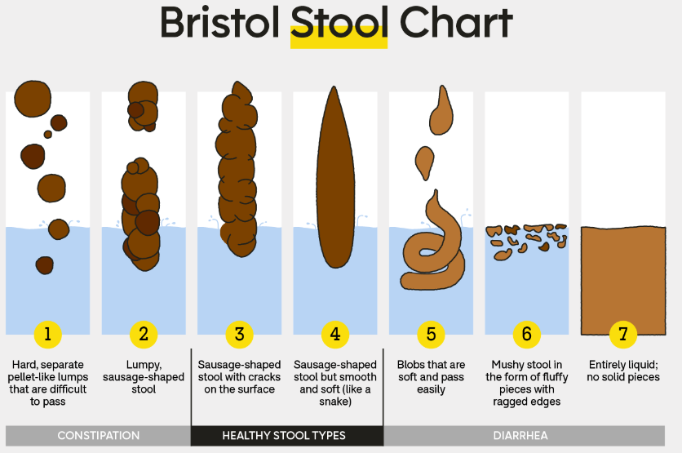
Toileting position

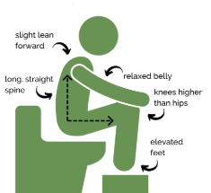


Pelvic health resources

- Aim for type 3 or 4, 3 times/day to once every 3 days by balancing fibre & fluid.
- Aim for 1.5-2L of water & 3 regular meals a day.
- Type 1-2: Add fibre/water.
- Type 5-7: Try a lower fibre diet.
- No ‘one diet fits all’ and it often takes time to find the right balance.
Image: GoodRx.com

- Complete for 3 consecutive days.
- Write down everything you eat & drink, including medication and the approx. time.
- When you pee, note the time it takes or amount small, medium or large.
- Write down any leaks and what happened i.e. ‘jumping’, ’on the way to the toilet’.
- Note amount: small (few drops), medium (wet underwear), large (wet through outer clothes).
- ‘Was urge present?’ - did you feel like your bladder was full when the leak occurred?
- At night, write down any time you wake to pee/poo & whether you wake up wet or dry.
- Record bowel movements.
- Pick your stool type 1-7 from the Bristol stool chart or whether it was difficult to pass/hold on to or clean yourself after.
- *Everyone has different stool habits that can occasionally change. If your stools are too hard or loose for a while talk to a dietitian or doctor.

Bladder & Bowel diary - Instructions

