


Urgency Urinary Incontinence:
Top Tips

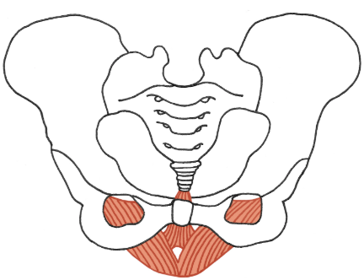
Managing urgency:

- Pelvic floor muscle training: ‘lift your back passage up and forwards towards your water passage’. Breathe and hold before releasing fully. Aim for: Slow 10secs x 10 reps, Fast: 10 reps, 3 times/day x 3 to 4 months

- Urge suppression techniques: Stay calm, breathe, distract, up/down on your toes, tap/scrunch toes, cross or squeeze legs together, count on fingertips “I am in control”

- Bladder training for 6 weeks: Bladder diary, look for triggers, ride the wave, +/- timed voiding
Bladder control & continence:
- The bladder can store 350-500mls of urine.
- Urgency urinary incontinence can cause a strong urge to pee before the bladder is full.
- An urge wave is a sudden, intense sensation of needing to pee and is caused by bladder muscle contractions. It can vary in duration.
- Urgency can lead to increased peeing frequency, leaking, anxiety and isolation.
- Running water, putting the key in the door or seeing a toilet door can trigger a sudden urge.

Things to try:
- Reduce caffeine, alcohol, fizzy drinks, spicy foods, tomato-based sauces & citrus drinks which can irritate the bladder.
- Drink ~2L/day fluids, stop ~2hrs before bed.
- Avoid peeing ‘just in case’. Aim to pee every 1.5-2hrs - increase time gap as able.
- Maintain a regular bowel routine (fluid, fibre & physical activity can help). *Individual nutritional care plan will help guide you*.

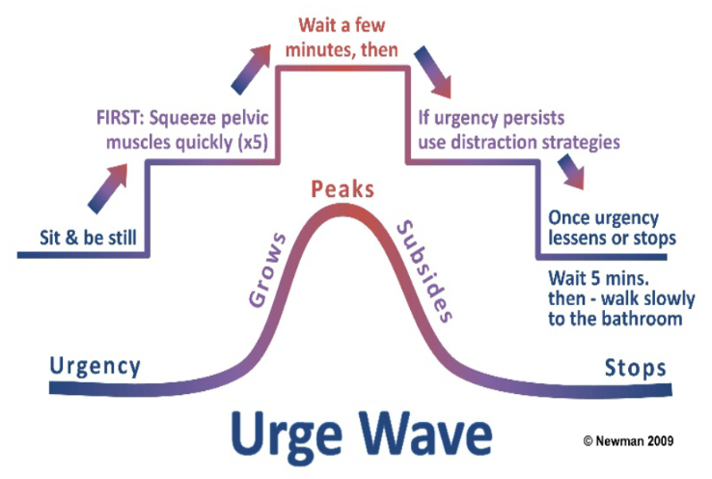

My main challenge was: ____________________________________

