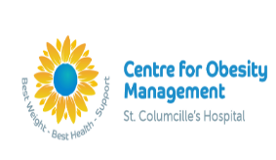Maintaining Muscle after Bariatric Surgery
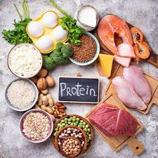+ = 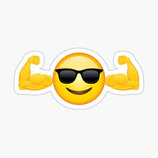

Why do I need protein?
Protein is an important nutrient that the body uses for repair and growth of cells, making hormones and enzymes, and supports healthy muscle.
After bariatric surgery, research shows that there is a loss of muscle. We focus on protein and resistance exercises to help keep muscle as healthy and strong as possible and to protect physical function.
Everyday rich sources of protein include meats, fish, poultry, eggs, milk, cheese, yogurts, nuts, beans, tofu, lentils, soya and Quorn.
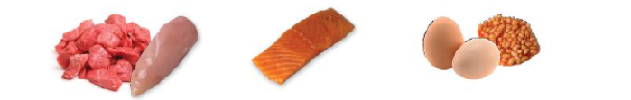

If you are struggling to meet your protein needs there are options with added protein levels e.g. prescribed protein drinks, protein milk, protein bars, protein yogurts, protein water and protein powders.

How much protein do I need?
It is important to have a minimum of 60g of protein each day for muscle health, however, most people will need more than this.
My individual protein needs are _____g per day to protect my muscle after bariatric surgery.

Tips for increasing protein?
- Know our proteins – this helps to choose foods that align with our health goals.
- Have a protein at each meal and snack to ensure enough protein over the day.
- 3 meals and 3 snacks a day to ensure plenty of chances to get enough protein in.
- Try protein milks or yogurts as they are higher in protein without being a larger amount of food.
- Including milk as a drink adds additional protein to the day. This can be by itself or in a milky drink e.g. a coffee.
- If you are on the go, bring a packed snack/meal or plan for what you can get out. Protein pouches, small protein milk cartons or deli meats or sandwiches can be good options.
What is Resistance Training? 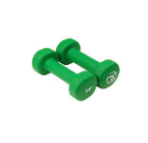 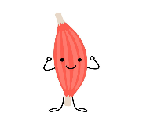
Resistance training involves movements that challenge our muscles by resisting weight or force. Doing resistance training repeatedly and consistently, builds stronger muscles.
Resistance Training post Bariatric Surgery
If your surgery is routine it is perfectly safe and strongly advised to start resistance training 4 weeks post-surgery to protect muscle health. Start with short bouts (5 to 10 minutes) of lifting small “dumbbell” weights (Female 1-3kg, Male 2-5kg). Build this up to 20 minutes with heavier weights with a minimum 3 days a week. If you don’t have dumbbells you can use bottles of water, resistance bands or your body weight. Repeat the movement until your muscles start to feel heavy or tired.

